Process of Science

How Do Environmental Changes Affect a Population?

Lab Notebook

Global Warming Data Table
Number of: | Size |  |  | Color
 | Large | Medium | Small | Black | Brown
Parental generation | 2 | 19 | 1 | 19 | 3
10th generation | 0 | 19 | 5 | 24 | 0
20th generation | 0 | 10 | 15 | 25 | 0
30th generation | 0 | 3 | 22 | 25 | 0

Graph your Global Warming data, using this key:
Large leafhoppers = •
Medium leafhoppers = O
Small leafhoppers = •

Black leafhoppers = X
Brown leafhoppers = X in color

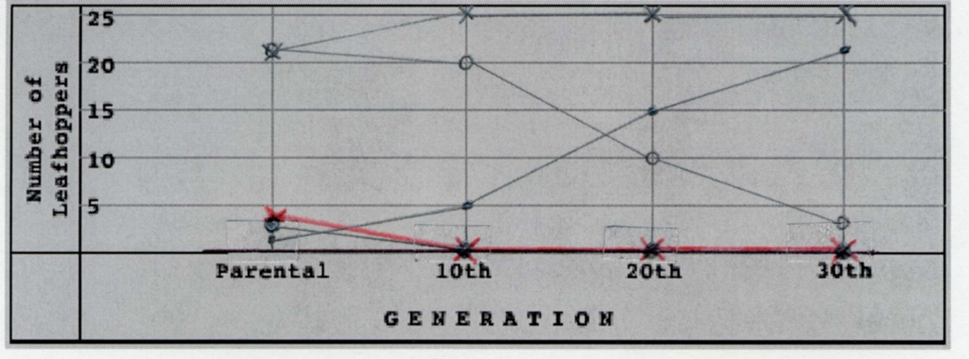

Predator Change Data Table
Number of: | Size |  |  | Color
 | Large | Medium | Small | Black | Brown
Parental generation | 1 | 21 | 1 | 20 | 3
10th generation | 0 | 15 | 1 | 6 | 10
20th generation | 0 | 10 | 1 | 4 | 15
30th generation | 0 | 25 | 0 | 2 | 23

Graph your Predator Change data:
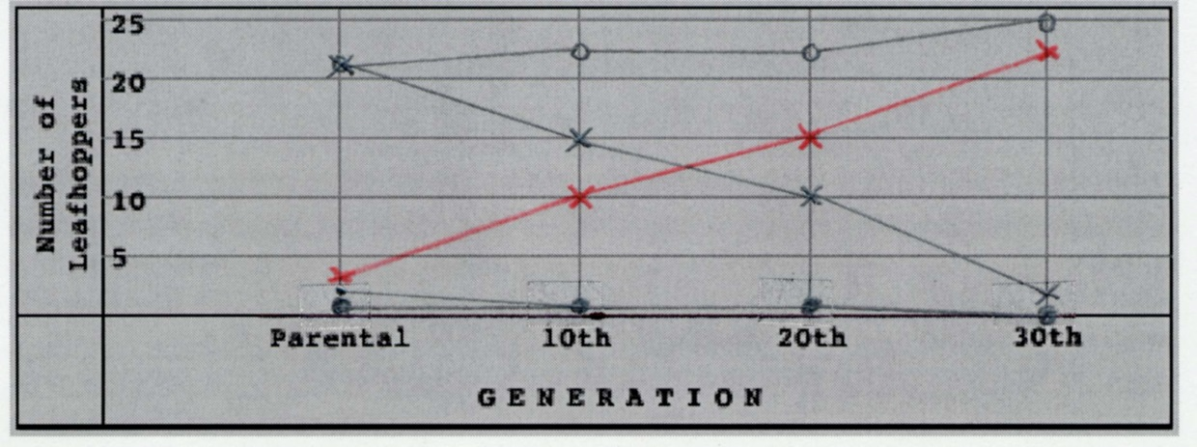

Vegetation Change Data Table
Number of: | Size |  |  | Color
 | Large | Medium | Small | Black | Brown
Parental generation | 2 | 20 | 1 | 20 | 3
10th generation | 1 | 22 | 1 | 22 | 2
20th generation | 0 | 25 | 1 | 23 | 1
30th generation | 0 | 25 | 0 | 25 | 0

Graph your Vegetation Change data:
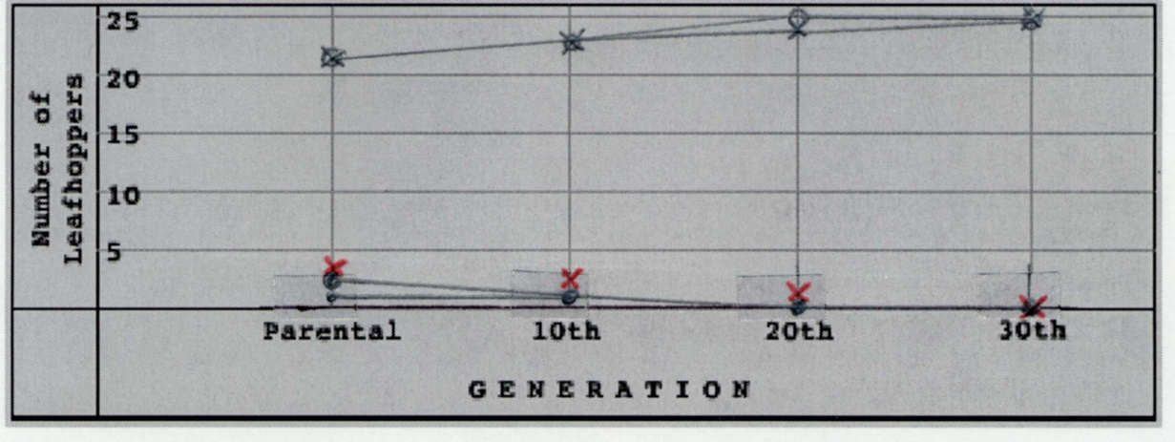

Pesticide Application Data Table
Number of: | Size |  |  | Color
 | Large | Medium | Small | Black | Brown
Parental generation | 2 | 21 | 0 | 20 | 3
10th generation | 5 | 20 | 0 | 24 | 1
20th generation | 10 | 15 | 0 | 25 | 0
30th generation | 21 | 2 | 0 | 23 | 0

Graph your Pesticide Application data:
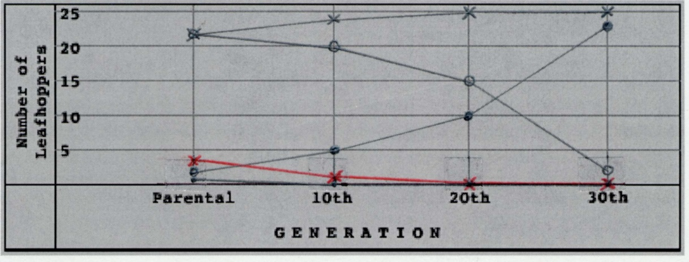

Questions

- What role does genetics play in the variation seen in this leafhopper population?

When a new element is added to the ecosystem it causes a genetic trait to become more useful and others less useful. This changes the criteria of what it means to be the “fittest for survival.”

- Note the results from the 20th generation under global warming conditions. Before continuing with the 30th generation, predict the population composition of the 30th generation.

Each 10 generations the population is becoming smaller and there are only black bugs at this point.

- What happened to the proportion of each type of leafhopper in subsequent generations under global warming conditions? Suggest a reason why the traits of the 30th generation make this population better adapted to its altered environment.

The next generation will become smaller perhaps due to having less surface area to keep warm. There may also be more small places to build shelter to avoid the cold temperatures.

- Why would you expect a change in predators to cause a difference in the types of leafhoppers being selected?

The black bugs might be easier for the predators to see. Given that most creatures are lazy they will go for the easier prey. Only after the low hanging fruit is picked will they climb higher in the tree.

- Note the differences between the parental, 10th and 20th generations when the predator changed from a bird to a snake. What evidence supports the view that leafhopper size is not affected by a change in predators?

The expected size of the bugs across the population did not change.

- What happened to the proportion of each type of leafhopper in subsequent generations when the predator changed from a bird to a snake? Suggest a reason why the traits predominant in the 30th generation make this population better adapted to the change in predators.
The bird might have been able to detect the size and color differently than the snake. This caused a change of the predator to change the desired traits. Another example of “survival of the luckiest.”

- Describe some human activities around your school that could have influenced the natural vegetation in the area.

The grounds keepers might tear down or grow up different plant life. Children littering might encourage different predators to come around more often. Change of pesticides.

- Note the differences between the parental and the 30th generations. What happened to the proportion of each type of leafhopper when the vegetation changed? Suggest a reason why the traits of the 30th generation make this population better adapted to its altered environment.

Different variants of the bugs might have preferred different foods. If the desired food becomes limited they will either starve or need to move. Over a few generations this results in only the ones that prefer the local food staying.

- Identify some major sources of pesticides in your area

The gardeners around our complex use them all the time; fumes from the vehicles; chemicals poured down the drain.

- What happened to the proportions of leafhoppers in each subsequent generation when pesticides were added to the environment? Explain why all the leafhoppers were not killed by the pesticide application.

A smaller group of them were resistant and were able to flourish in the now abundant resources. This is similar to the key point of the “antibacterial resistant assignment.”

